^{EX NO:3} DATE: | Configure DNS and DHCP protocols using Packet Tracer

Objectives:
(i) To configure and verify the DHCP protocol for automatic IP address allocation to client devices in a network.
(ii) To configure and test the DNS protocol for translating domain names into IP addresses and enabling access to network resources using hostnames.
Software/Apparatus required:
(i) Cisco Packet Tracer
(ii) End Devices (PCs)
(iii) Switches
(iv) Copper Straight-through Cable / Automatic Cable Selector
(v) Routers
(vi) Server (DNS, HTTP and DHCP)
Procedure:
Objective 1: DHCP protocol
1. Create the required network topology using switches, a server, and PCs. 2. Connect all devices using appropriate network cables.
3. Open the server and enable the DHCP service.
4. Create a DHCP pool and specify the network parameters.
5. Configure the server with a static network address.
6. Open each PC and select DHCP in the IP Configuration settings.
7. Verify that the PCs automatically receive network configuration from the DHCP server. 8. Test communication between the PCs and the server using the ping command. 9. Save the Packet Tracer project.
Objective 2: DNS protocol
1. Create the network topology using PCs, switches, a router, a DNS server, and a web server.
2. Connect all devices using appropriate network cables.
3. Configure the router interfaces and enable communication between the networks. 4. Assign network addresses to all PCs, servers, and router interfaces.
5. Open the DNS server and enable the DNS service.
6. Create DNS records to map domain names to the web server.
7. Open the web server and enable the HTTP service.
8. Create and save the required web pages on the web server.
9. Configure the PCs with the DNS server address.
10. Open a web browser on any PC and access the website using the configured domain name.
11. Verify that the webpage is displayed correctly and test connectivity using the ping command.
12. Save the Packet Tracer project.
Diagram
Objective 1: DHCP protocol
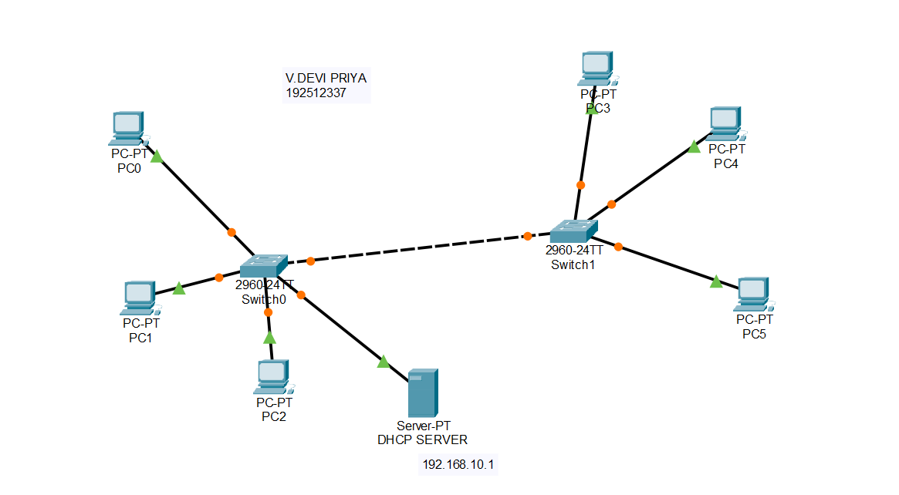
Objective 2: DNS protocol
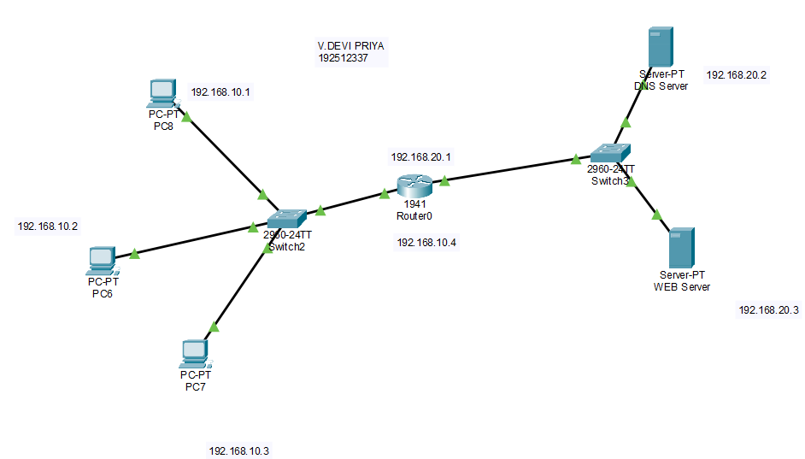 Output:
Objective 1: DHCP protocol
SI.
Source IP Destination IP Data sent (bytes) Data received No
(bytes)
SI.  No | Source IP | Destination IP | Data sent (bytes) | Data received (bytes)
1 | 192.168.10.1 | 192.168.10.5 | 32 | 32
2 | 192.168.10.2 | 192.168.10.1 | 32 | 32
3 | 192.168.10.3 | 192.168.10.3 | 32 | 32
4 | 192.168.10.4 | 192.168.10.2 | 32 | 32
5 | 192.168.10.5 | 192.168.10.4 | 32 | 32

Objective 2: DNS protocol
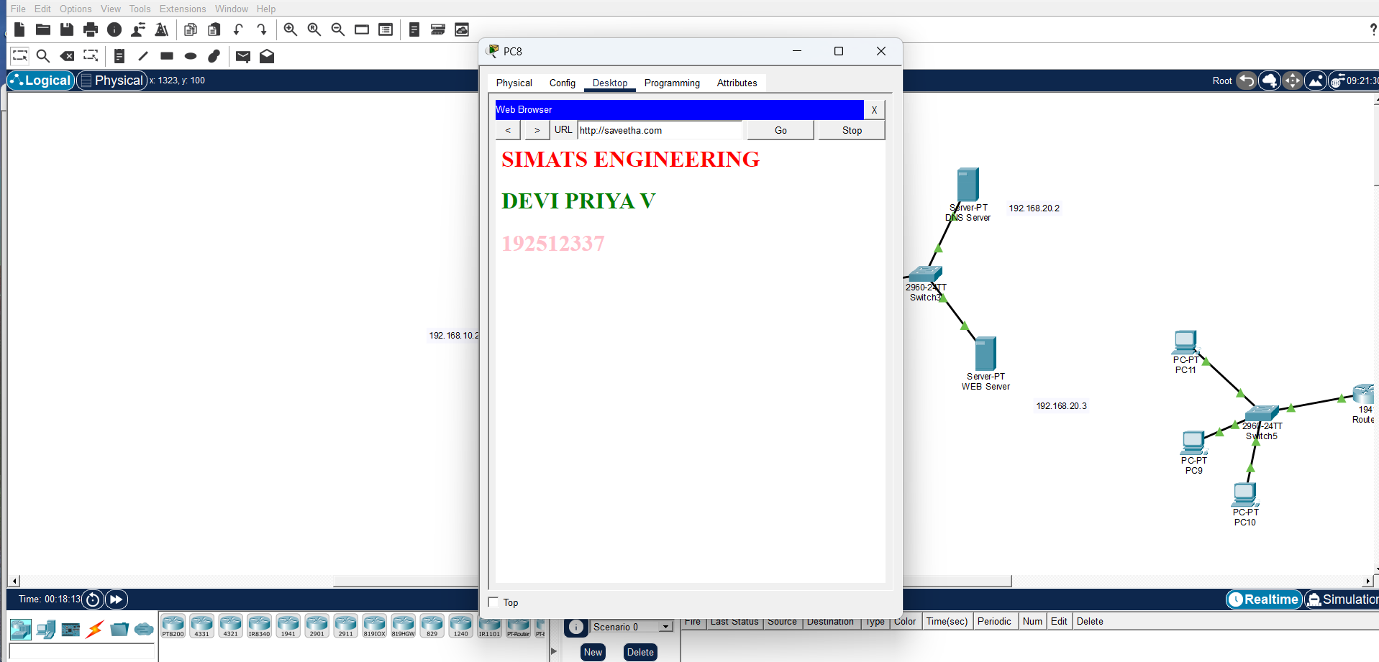
Results
Objective 1: DHCP Protocol
(i) The DHCP protocol was successfully configured, and the client devices automatically obtained network configuration parameters from the DHCP server.
Objective 2: DNS Protocol
(ii) The DNS protocol was successfully configured, and the configured domain names were successfully resolved to access the web server using hostnames.

